3_WORDS_RESULTS
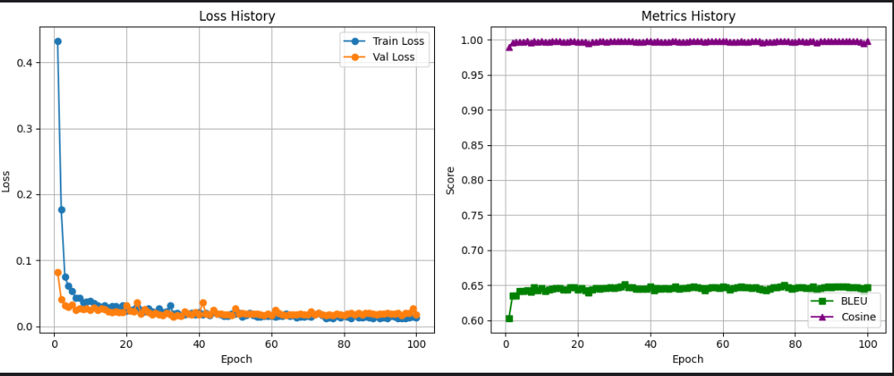

epoch | train_loss | val_loss | bleu | cosine
1 | 0.432654 | 0.082592 | 0.602335 | 0.989161
2 | 0.176599 | 0.041134 | 0.635153 | 0.996604
3 | 0.075105 | 0.031796 | 0.634502 | 0.996653
4 | 0.061233 | 0.029638 | 0.641114 | 0.997563
5 | 0.05395 | 0.033246 | 0.641053 | 0.997265
6 | 0.043321 | 0.025312 | 0.642303 | 0.998061
7 | 0.043519 | 0.027643 | 0.640329 | 0.996496
8 | 0.035788 | 0.025952 | 0.647404 | 0.998161
9 | 0.037917 | 0.027335 | 0.642316 | 0.996893
10 | 0.038294 | 0.024512 | 0.646335 | 0.998228
11 | 0.034701 | 0.028777 | 0.641505 | 0.997165
12 | 0.032217 | 0.024665 | 0.643724 | 0.997534
13 | 0.029294 | 0.027004 | 0.644914 | 0.997837
14 | 0.032173 | 0.025706 | 0.6453 | 0.998047
15 | 0.028844 | 0.022821 | 0.645978 | 0.997946
16 | 0.03011 | 0.021755 | 0.643933 | 0.99734
17 | 0.030922 | 0.022351 | 0.643688 | 0.997341
18 | 0.02709 | 0.021316 | 0.646524 | 0.998135
19 | 0.031689 | 0.020935 | 0.64717 | 0.997928
20 | 0.024105 | 0.031724 | 0.644054 | 0.996893
21 | 0.024525 | 0.023452 | 0.646267 | 0.997566
22 | 0.025981 | 0.022155 | 0.643067 | 0.997538
23 | 0.03046 | 0.035839 | 0.638922 | 0.99512
24 | 0.024686 | 0.019255 | 0.643555 | 0.996928
25 | 0.022893 | 0.026396 | 0.645897 | 0.997406
26 | 0.027179 | 0.021159 | 0.64462 | 0.997752
27 | 0.022272 | 0.017919 | 0.645551 | 0.997975
28 | 0.021408 | 0.019967 | 0.64563 | 0.997593
29 | 0.026615 | 0.018281 | 0.646577 | 0.998275
30 | 0.020911 | 0.017406 | 0.646035 | 0.998137
31 | 0.022619 | 0.020151 | 0.646922 | 0.997831
32 | 0.03129 | 0.017448 | 0.648491 | 0.998506
33 | 0.018896 | 0.014983 | 0.650815 | 0.998321
34 | 0.020247 | 0.016468 | 0.646791 | 0.997836
35 | 0.017262 | 0.015802 | 0.647284 | 0.997959
36 | 0.018452 | 0.022841 | 0.644892 | 0.997349
37 | 0.018682 | 0.019607 | 0.644919 | 0.997544
38 | 0.020464 | 0.0185 | 0.644903 | 0.997504
39 | 0.018446 | 0.020926 | 0.644755 | 0.998071
40 | 0.020929 | 0.017454 | 0.647504 | 0.998353
41 | 0.018329 | 0.03631 | 0.642467 | 0.996904
42 | 0.020639 | 0.018862 | 0.64577 | 0.99787
43 | 0.016609 | 0.017922 | 0.64484 | 0.997298
44 | 0.021558 | 0.024515 | 0.645348 | 0.99724
45 | 0.018657 | 0.018995 | 0.644367 | 0.997375
46 | 0.017449 | 0.018857 | 0.64573 | 0.998125
47 | 0.015203 | 0.017886 | 0.648124 | 0.99836
48 | 0.015865 | 0.018039 | 0.644488 | 0.99723
49 | 0.019316 | 0.017372 | 0.645852 | 0.997649
50 | 0.018815 | 0.0273 | 0.645939 | 0.997214
51 | 0.020285 | 0.019301 | 0.646415 | 0.998091
52 | 0.014145 | 0.02059 | 0.647481 | 0.998322
53 | 0.017132 | 0.019288 | 0.647325 | 0.998014
54 | 0.020196 | 0.019585 | 0.645313 | 0.998016
55 | 0.017247 | 0.019672 | 0.642406 | 0.996835
56 | 0.014876 | 0.018713 | 0.646135 | 0.99798
57 | 0.014591 | 0.017861 | 0.647401 | 0.997903
58 | 0.01621 | 0.017215 | 0.646801 | 0.997823
59 | 0.016047 | 0.018617 | 0.646149 | 0.997819
60 | 0.015211 | 0.016924 | 0.648088 | 0.998337
61 | 0.014575 | 0.024753 | 0.646902 | 0.997814
62 | 0.015375 | 0.02057 | 0.643557 | 0.997147
63 | 0.015636 | 0.018141 | 0.646119 | 0.997452
64 | 0.019479 | 0.017042 | 0.64668 | 0.997452
65 | 0.015895 | 0.017798 | 0.647862 | 0.998328
66 | 0.01719 | 0.017674 | 0.646913 | 0.996961
67 | 0.013151 | 0.018159 | 0.646911 | 0.997653
68 | 0.01511 | 0.018632 | 0.646116 | 0.998105
69 | 0.014543 | 0.01843 | 0.646414 | 0.998056
70 | 0.016271 | 0.018541 | 0.644772 | 0.997975
71 | 0.014496 | 0.022627 | 0.643432 | 0.996198
72 | 0.017537 | 0.018049 | 0.642308 | 0.997454
73 | 0.020105 | 0.019823 | 0.644288 | 0.997521
74 | 0.016647 | 0.017454 | 0.647072 | 0.997472
75 | 0.012318 | 0.017188 | 0.647171 | 0.997892
76 | 0.013096 | 0.017834 | 0.647662 | 0.998096
77 | 0.012831 | 0.017075 | 0.649744 | 0.998532
78 | 0.015634 | 0.019363 | 0.647082 | 0.998124
79 | 0.013232 | 0.017619 | 0.644343 | 0.996686
80 | 0.015988 | 0.017252 | 0.646318 | 0.997388
81 | 0.014274 | 0.018725 | 0.64691 | 0.997949
82 | 0.012033 | 0.020304 | 0.647077 | 0.997942
83 | 0.01691 | 0.018357 | 0.645622 | 0.997403
84 | 0.013949 | 0.019941 | 0.645747 | 0.998206
85 | 0.013478 | 0.01845 | 0.647718 | 0.99806
86 | 0.014613 | 0.019771 | 0.64413 | 0.995623
87 | 0.013044 | 0.020563 | 0.645544 | 0.997881
88 | 0.012223 | 0.019474 | 0.646746 | 0.997948
89 | 0.016384 | 0.017704 | 0.647429 | 0.997721
90 | 0.012767 | 0.018936 | 0.646625 | 0.998125
91 | 0.013011 | 0.019376 | 0.647446 | 0.998312
92 | 0.011906 | 0.020089 | 0.647456 | 0.998138
93 | 0.015299 | 0.019451 | 0.648193 | 0.998117
94 | 0.014901 | 0.019606 | 0.647972 | 0.998045
95 | 0.012845 | 0.020391 | 0.646602 | 0.997837
96 | 0.01281 | 0.017418 | 0.646671 | 0.997835
97 | 0.012096 | 0.019985 | 0.646863 | 0.99825
98 | 0.012972 | 0.020176 | 0.64633 | 0.997529
99 | 0.0147 | 0.02704 | 0.641224 | 0.994707
100 | 0.013751 | 0.017683 | 0.646611 | 0.997785

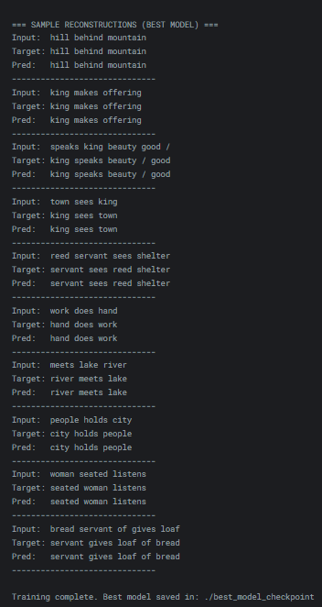
https://www.kaggle.com/code/ahmed3khaled/bart-3-words-english

4_WORDS_RESULTS
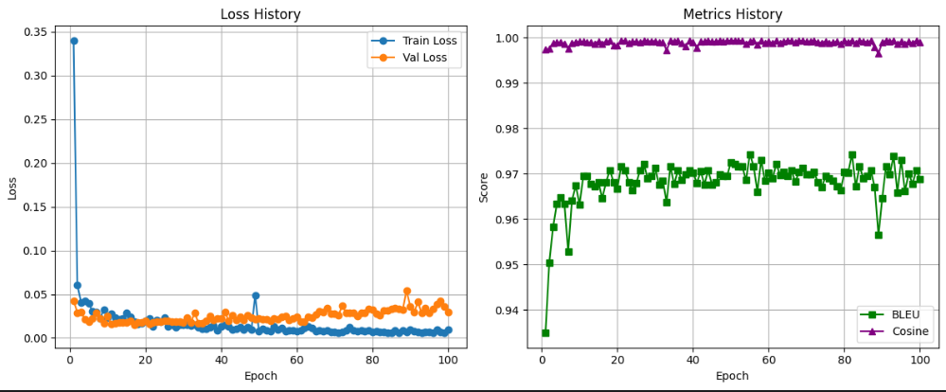

epoch | train_loss | val_loss | bleu | cosine
1 | 0.339855 | 0.042683 | 0.934855 | 0.997292
2 | 0.060421 | 0.029004 | 0.950305 | 0.997498
3 | 0.040521 | 0.029398 | 0.958195 | 0.998787
4 | 0.042064 | 0.021449 | 0.963309 | 0.998955
5 | 0.039886 | 0.019023 | 0.964664 | 0.998981
6 | 0.030157 | 0.021907 | 0.963427 | 0.998672
7 | 0.029501 | 0.028836 | 0.952796 | 0.997495
8 | 0.022415 | 0.022599 | 0.964092 | 0.998753
9 | 0.032027 | 0.017209 | 0.967335 | 0.999031
10 | 0.023041 | 0.024743 | 0.963234 | 0.99906
11 | 0.027971 | 0.015611 | 0.969444 | 0.999161
12 | 0.023369 | 0.017084 | 0.969503 | 0.999003
13 | 0.021179 | 0.017481 | 0.967732 | 0.998904
14 | 0.021886 | 0.017683 | 0.967217 | 0.998642
15 | 0.028493 | 0.017366 | 0.968129 | 0.999188
16 | 0.023971 | 0.019457 | 0.964526 | 0.998633
17 | 0.018592 | 0.014569 | 0.968081 | 0.999136
18 | 0.01551 | 0.017595 | 0.970773 | 0.999223
19 | 0.016577 | 0.018116 | 0.968075 | 0.998174
20 | 0.019321 | 0.019456 | 0.966697 | 0.998216
21 | 0.02212 | 0.016244 | 0.971654 | 0.99924
22 | 0.013149 | 0.017662 | 0.970724 | 0.999234
23 | 0.02062 | 0.018325 | 0.968147 | 0.998722
24 | 0.018818 | 0.018268 | 0.96631 | 0.999083
25 | 0.023052 | 0.019983 | 0.967846 | 0.999082
26 | 0.013038 | 0.019958 | 0.970758 | 0.998964
27 | 0.015281 | 0.018525 | 0.972095 | 0.999285
28 | 0.012515 | 0.018639 | 0.968962 | 0.999186
29 | 0.014613 | 0.018473 | 0.96951 | 0.999195
30 | 0.015057 | 0.017445 | 0.971165 | 0.999221
31 | 0.014974 | 0.023579 | 0.967516 | 0.998911
32 | 0.014419 | 0.017523 | 0.968513 | 0.999
33 | 0.01536 | 0.028671 | 0.963697 | 0.997215
34 | 0.01264 | 0.017227 | 0.971606 | 0.999265
35 | 0.010405 | 0.016818 | 0.96764 | 0.999175
36 | 0.010232 | 0.019847 | 0.970724 | 0.999234
37 | 0.012 | 0.025317 | 0.968606 | 0.998762
38 | 0.013862 | 0.020389 | 0.969842 | 0.998076
39 | 0.008721 | 0.022431 | 0.970773 | 0.999259
40 | 0.013443 | 0.021874 | 0.970268 | 0.999014
41 | 0.015281 | 0.029513 | 0.967875 | 0.997729
42 | 0.013519 | 0.019962 | 0.9705 | 0.999055
43 | 0.009136 | 0.025987 | 0.967632 | 0.999137
44 | 0.010593 | 0.020148 | 0.970724 | 0.999258
45 | 0.012133 | 0.024305 | 0.967632 | 0.999089
46 | 0.009329 | 0.02025 | 0.968073 | 0.999086
47 | 0.01205 | 0.02594 | 0.969892 | 0.999282
48 | 0.009541 | 0.023307 | 0.969444 | 0.999189
49 | 0.048955 | 0.021722 | 0.969451 | 0.999234
50 | 0.007441 | 0.022668 | 0.972536 | 0.999316
51 | 0.010492 | 0.020998 | 0.972087 | 0.999262
52 | 0.008571 | 0.021013 | 0.971606 | 0.99926
53 | 0.007452 | 0.019915 | 0.971606 | 0.999277
54 | 0.012915 | 0.022664 | 0.968539 | 0.998565
55 | 0.009182 | 0.020936 | 0.974283 | 0.999172
56 | 0.011114 | 0.023637 | 0.971647 | 0.999263
57 | 0.008133 | 0.025313 | 0.966003 | 0.998513
58 | 0.008901 | 0.020684 | 0.973025 | 0.99931
59 | 0.008923 | 0.021923 | 0.968397 | 0.998761
60 | 0.007537 | 0.023716 | 0.970268 | 0.999047
61 | 0.008314 | 0.018456 | 0.968939 | 0.998838
62 | 0.011308 | 0.018479 | 0.972087 | 0.99923
63 | 0.012847 | 0.023714 | 0.969711 | 0.998844
64 | 0.011424 | 0.022932 | 0.970276 | 0.99919
65 | 0.007509 | 0.026787 | 0.969402 | 0.999238
66 | 0.008378 | 0.030856 | 0.970724 | 0.999268
67 | 0.008073 | 0.029439 | 0.968165 | 0.998874
68 | 0.008525 | 0.033694 | 0.970284 | 0.999253
69 | 0.007061 | 0.027625 | 0.971214 | 0.99925
70 | 0.00704 | 0.027557 | 0.969828 | 0.999123
71 | 0.006298 | 0.02569 | 0.969884 | 0.999196
72 | 0.006548 | 0.036962 | 0.970284 | 0.999251
73 | 0.008444 | 0.028779 | 0.968098 | 0.998992
74 | 0.011908 | 0.028876 | 0.966959 | 0.998863
75 | 0.008365 | 0.028971 | 0.969395 | 0.999164
76 | 0.00783 | 0.025265 | 0.96898 | 0.998842
77 | 0.00903 | 0.02898 | 0.968501 | 0.99899
78 | 0.007427 | 0.028911 | 0.967192 | 0.999098
79 | 0.008254 | 0.032787 | 0.966395 | 0.998681
80 | 0.006933 | 0.032372 | 0.970284 | 0.999236
81 | 0.007923 | 0.027384 | 0.970208 | 0.998957
82 | 0.006935 | 0.025553 | 0.974298 | 0.99936
83 | 0.006678 | 0.031039 | 0.967168 | 0.998759
84 | 0.005925 | 0.031237 | 0.971647 | 0.999253
85 | 0.005592 | 0.033156 | 0.968905 | 0.99919
86 | 0.008951 | 0.033988 | 0.969436 | 0.999023
87 | 0.006318 | 0.033066 | 0.970717 | 0.999224
88 | 0.0085 | 0.032186 | 0.966945 | 0.997821
89 | 0.007214 | 0.054395 | 0.956434 | 0.996427
90 | 0.009116 | 0.035672 | 0.964597 | 0.999032
91 | 0.007416 | 0.029342 | 0.971654 | 0.999287
92 | 0.006693 | 0.041064 | 0.969828 | 0.999122
93 | 0.00602 | 0.028243 | 0.97385 | 0.999263
94 | 0.006656 | 0.033761 | 0.965831 | 0.998574
95 | 0.006387 | 0.029071 | 0.972961 | 0.999148
96 | 0.00562 | 0.033228 | 0.966163 | 0.998666
97 | 0.009182 | 0.038366 | 0.969992 | 0.999069
98 | 0.006429 | 0.042225 | 0.967774 | 0.998803
99 | 0.005962 | 0.03599 | 0.970773 | 0.999276
100 | 0.009362 | 0.029642 | 0.968741 | 0.998897

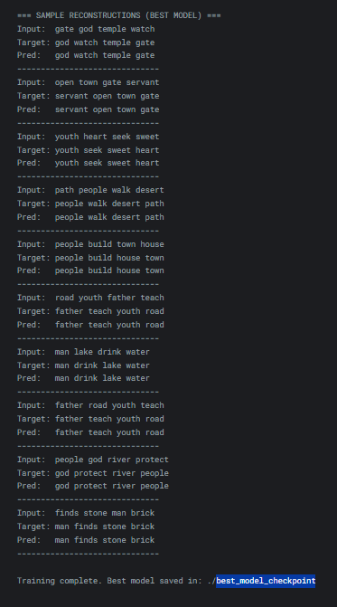
https://www.kaggle.com/code/immortusdeimmortal/bart-4-words-english

5_WORDS_RESULTS
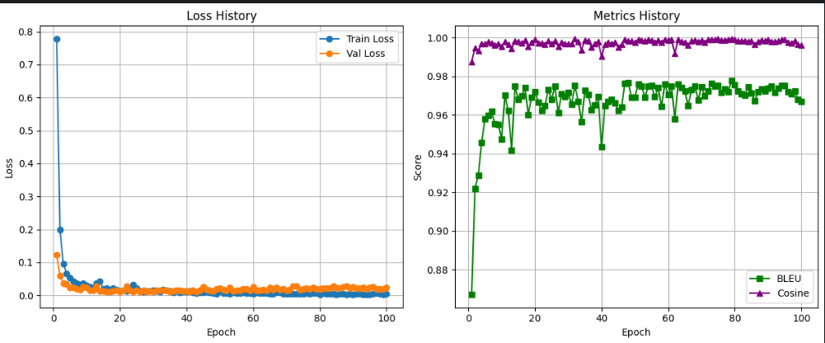

epoch | train_loss | val_loss | bleu | cosine
1 | 0.778475 | 0.12329 | 0.866998 | 0.987499
2 | 0.199693 | 0.060895 | 0.921944 | 0.994448
3 | 0.096169 | 0.036547 | 0.928805 | 0.99324
4 | 0.067022 | 0.035248 | 0.945766 | 0.996591
5 | 0.053562 | 0.024301 | 0.958026 | 0.996777
6 | 0.042082 | 0.024157 | 0.959827 | 0.997708
7 | 0.036942 | 0.019212 | 0.961665 | 0.997264
8 | 0.032066 | 0.018664 | 0.955326 | 0.996023
9 | 0.036086 | 0.025603 | 0.955078 | 0.996931
10 | 0.030831 | 0.023364 | 0.947586 | 0.99537
11 | 0.026756 | 0.014924 | 0.970044 | 0.997729
12 | 0.024596 | 0.015954 | 0.962139 | 0.996566
13 | 0.036874 | 0.028031 | 0.9418 | 0.994126
14 | 0.042003 | 0.012707 | 0.974843 | 0.998273
15 | 0.019768 | 0.012362 | 0.96801 | 0.997867
16 | 0.02142 | 0.011177 | 0.969664 | 0.997006
17 | 0.015587 | 0.0111 | 0.97406 | 0.99842
18 | 0.0224 | 0.012573 | 0.960124 | 0.995429
19 | 0.017977 | 0.015223 | 0.969131 | 0.997602
20 | 0.013086 | 0.011753 | 0.971829 | 0.998796
21 | 0.014761 | 0.01534 | 0.966681 | 0.996968
22 | 0.012803 | 0.027289 | 0.962182 | 0.99724
23 | 0.021792 | 0.015003 | 0.964636 | 0.996466
24 | 0.032392 | 0.012071 | 0.972866 | 0.998162
25 | 0.021462 | 0.015819 | 0.967969 | 0.996701
26 | 0.012457 | 0.011293 | 0.974793 | 0.998269
27 | 0.011011 | 0.015744 | 0.960978 | 0.995236
28 | 0.012514 | 0.01124 | 0.970965 | 0.997635
29 | 0.014088 | 0.012369 | 0.969222 | 0.996922
30 | 0.01626 | 0.011699 | 0.971611 | 0.996617
31 | 0.012982 | 0.014471 | 0.965258 | 0.996621
32 | 0.01175 | 0.016221 | 0.974984 | 0.99915
33 | 0.018272 | 0.01553 | 0.966894 | 0.997894
34 | 0.015466 | 0.015473 | 0.956346 | 0.993497
35 | 0.012706 | 0.011882 | 0.972461 | 0.998729
36 | 0.00859 | 0.014099 | 0.970443 | 0.998235
37 | 0.013327 | 0.014752 | 0.962373 | 0.994869
38 | 0.009919 | 0.015769 | 0.965119 | 0.996655
39 | 0.011987 | 0.013712 | 0.969436 | 0.997888
40 | 0.010543 | 0.013772 | 0.943323 | 0.990108
41 | 0.012544 | 0.011954 | 0.964804 | 0.996559
42 | 0.009259 | 0.015877 | 0.967047 | 0.997527
43 | 0.007238 | 0.011249 | 0.967889 | 0.996713
44 | 0.008548 | 0.015062 | 0.966106 | 0.997573
45 | 0.009124 | 0.025347 | 0.962245 | 0.995133
46 | 0.010833 | 0.017484 | 0.963898 | 0.996363
47 | 0.008547 | 0.015898 | 0.976339 | 0.998855
48 | 0.007636 | 0.013583 | 0.976535 | 0.998172
49 | 0.004737 | 0.019595 | 0.96904 | 0.998127
50 | 0.014203 | 0.021819 | 0.969038 | 0.997377
51 | 0.007975 | 0.017338 | 0.975864 | 0.999048
52 | 0.006434 | 0.014643 | 0.974857 | 0.998434
53 | 0.005545 | 0.023144 | 0.969138 | 0.998085
54 | 0.009947 | 0.014015 | 0.974756 | 0.998813
55 | 0.007642 | 0.015733 | 0.975047 | 0.99861
56 | 0.007581 | 0.015598 | 0.96922 | 0.997565
57 | 0.008542 | 0.020189 | 0.974122 | 0.99858
58 | 0.007444 | 0.019685 | 0.964201 | 0.997489
59 | 0.006483 | 0.016345 | 0.975983 | 0.998894
60 | 0.004005 | 0.026369 | 0.970356 | 0.998414
61 | 0.009468 | 0.016209 | 0.974851 | 0.998751
62 | 0.007676 | 0.01545 | 0.957762 | 0.991772
63 | 0.007621 | 0.016643 | 0.976024 | 0.998859
64 | 0.007581 | 0.01581 | 0.974202 | 0.997983
65 | 0.004328 | 0.024589 | 0.972246 | 0.997619
66 | 0.005298 | 0.01803 | 0.964579 | 0.996001
67 | 0.008307 | 0.022978 | 0.972901 | 0.99831
68 | 0.008984 | 0.017435 | 0.974736 | 0.998494
69 | 0.005819 | 0.019425 | 0.967699 | 0.997962
70 | 0.004889 | 0.015425 | 0.974367 | 0.998487
71 | 0.005445 | 0.018004 | 0.969927 | 0.997342
72 | 0.004482 | 0.027656 | 0.972139 | 0.99894
73 | 0.005815 | 0.027249 | 0.976198 | 0.998895
74 | 0.004434 | 0.018295 | 0.974697 | 0.99877
75 | 0.00549 | 0.019525 | 0.975235 | 0.999125
76 | 0.007703 | 0.021453 | 0.971409 | 0.99844
77 | 0.004381 | 0.018735 | 0.973421 | 0.998714
78 | 0.007242 | 0.024178 | 0.971913 | 0.999004
79 | 0.006865 | 0.020534 | 0.977623 | 0.999387
80 | 0.002861 | 0.01893 | 0.975434 | 0.998897
81 | 0.006129 | 0.021405 | 0.972284 | 0.998239
82 | 0.00418 | 0.021062 | 0.970866 | 0.998311
83 | 0.003895 | 0.021887 | 0.969948 | 0.998357
84 | 0.003955 | 0.029099 | 0.974573 | 0.997871
85 | 0.00365 | 0.023934 | 0.971335 | 0.998366
86 | 0.005868 | 0.021349 | 0.967087 | 0.996384
87 | 0.005489 | 0.025452 | 0.971812 | 0.997929
88 | 0.003422 | 0.027585 | 0.97326 | 0.998634
89 | 0.004776 | 0.021776 | 0.972196 | 0.998138
90 | 0.00275 | 0.026547 | 0.973771 | 0.998853
91 | 0.004619 | 0.022292 | 0.974653 | 0.998023
92 | 0.005541 | 0.022306 | 0.971621 | 0.997918
93 | 0.002118 | 0.024991 | 0.973859 | 0.998122
94 | 0.003264 | 0.020496 | 0.975229 | 0.998819
95 | 0.002249 | 0.024974 | 0.975072 | 0.999037
96 | 0.005195 | 0.025464 | 0.971911 | 0.997484
97 | 0.006134 | 0.020002 | 0.970876 | 0.997117
98 | 0.005198 | 0.020783 | 0.972394 | 0.998337
99 | 0.003049 | 0.020075 | 0.967885 | 0.996313
100 | 0.005206 | 0.02395 | 0.966753 | 0.995893

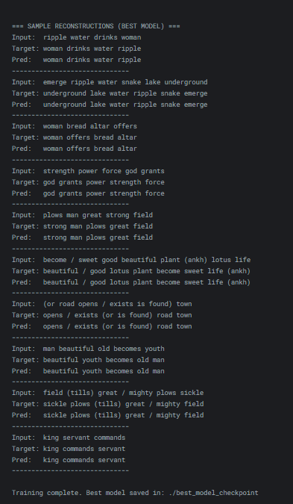
https://www.kaggle.com/code/demaciandedemacian/bart-5-words-english

6_WORDS_RESULTS
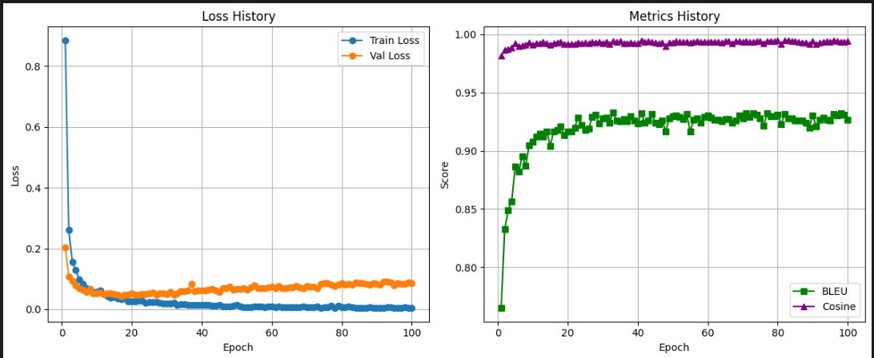

epoch | train_loss | val_loss | bleu | cosine
1 | 0.88511 | 0.204822 | 0.764889 | 0.981602
2 | 0.260333 | 0.108655 | 0.832848 | 0.986814
3 | 0.156556 | 0.093891 | 0.849262 | 0.987333
4 | 0.129921 | 0.0802 | 0.85676 | 0.988886
5 | 0.097358 | 0.069079 | 0.886644 | 0.992096
6 | 0.083589 | 0.064302 | 0.882078 | 0.989603
7 | 0.070591 | 0.056586 | 0.895376 | 0.990518
8 | 0.065528 | 0.066616 | 0.887144 | 0.991184
9 | 0.057798 | 0.053341 | 0.90501 | 0.993146
10 | 0.056937 | 0.053086 | 0.907539 | 0.990916
11 | 0.061406 | 0.054267 | 0.912379 | 0.992504
12 | 0.050853 | 0.05043 | 0.914794 | 0.992656
13 | 0.042 | 0.051673 | 0.9123 | 0.993308
14 | 0.037837 | 0.052205 | 0.91673 | 0.992354
15 | 0.041248 | 0.050743 | 0.90418 | 0.991415
16 | 0.03591 | 0.048398 | 0.916531 | 0.992552
17 | 0.032524 | 0.044256 | 0.917965 | 0.993293
18 | 0.039941 | 0.047184 | 0.92124 | 0.993495
19 | 0.026487 | 0.04683 | 0.913293 | 0.991924
20 | 0.027311 | 0.05184 | 0.916821 | 0.99195
21 | 0.026531 | 0.048441 | 0.916431 | 0.991718
22 | 0.029774 | 0.048731 | 0.919954 | 0.991892
23 | 0.028264 | 0.050932 | 0.928796 | 0.993227
24 | 0.022391 | 0.050719 | 0.921989 | 0.992365
25 | 0.024989 | 0.052068 | 0.917571 | 0.992715
26 | 0.023 | 0.055752 | 0.919027 | 0.992213
27 | 0.022785 | 0.048627 | 0.929233 | 0.993688
28 | 0.020792 | 0.051702 | 0.930715 | 0.992957
29 | 0.020213 | 0.052193 | 0.923336 | 0.993691
30 | 0.018622 | 0.049408 | 0.927951 | 0.992658
31 | 0.020108 | 0.056734 | 0.9287 | 0.993812
32 | 0.022606 | 0.048523 | 0.924296 | 0.991525
33 | 0.013599 | 0.051563 | 0.933133 | 0.993979
34 | 0.016053 | 0.058756 | 0.926004 | 0.993316
35 | 0.017406 | 0.059037 | 0.925515 | 0.993967
36 | 0.015343 | 0.061757 | 0.927501 | 0.9924
37 | 0.015231 | 0.084767 | 0.925095 | 0.992565
38 | 0.01482 | 0.059577 | 0.929895 | 0.993134
39 | 0.013299 | 0.062168 | 0.925962 | 0.992603
40 | 0.013558 | 0.063128 | 0.923387 | 0.992241
41 | 0.014089 | 0.06138 | 0.932531 | 0.99463
42 | 0.014332 | 0.063638 | 0.924058 | 0.99372
43 | 0.0123 | 0.067698 | 0.926051 | 0.993955
44 | 0.011923 | 0.062185 | 0.931579 | 0.993561
45 | 0.013553 | 0.058264 | 0.924235 | 0.992724
46 | 0.009577 | 0.069796 | 0.922766 | 0.992623
47 | 0.009787 | 0.070478 | 0.926205 | 0.993182
48 | 0.010225 | 0.075149 | 0.916313 | 0.990049
49 | 0.012524 | 0.065888 | 0.928096 | 0.993167
50 | 0.013811 | 0.068195 | 0.929591 | 0.993119
51 | 0.010136 | 0.0668 | 0.930099 | 0.99403
52 | 0.007876 | 0.068994 | 0.928905 | 0.993547
53 | 0.007706 | 0.063721 | 0.927482 | 0.993713
54 | 0.00732 | 0.071431 | 0.931543 | 0.993592
55 | 0.009589 | 0.079428 | 0.916409 | 0.992752
56 | 0.009514 | 0.070638 | 0.926902 | 0.99369
57 | 0.009464 | 0.069707 | 0.927733 | 0.994365
58 | 0.008003 | 0.069485 | 0.923818 | 0.993378
59 | 0.0105 | 0.072867 | 0.928826 | 0.99378
60 | 0.00991 | 0.07324 | 0.930422 | 0.99355
61 | 0.006483 | 0.069167 | 0.928536 | 0.993561
62 | 0.009324 | 0.075945 | 0.926854 | 0.993791
63 | 0.008043 | 0.069541 | 0.926845 | 0.993453
64 | 0.006795 | 0.068858 | 0.925524 | 0.992989
65 | 0.007946 | 0.072835 | 0.927347 | 0.993948
66 | 0.006672 | 0.072509 | 0.927372 | 0.994201
67 | 0.006262 | 0.077545 | 0.923933 | 0.992059
68 | 0.006646 | 0.071417 | 0.925857 | 0.994296
69 | 0.009328 | 0.06951 | 0.930605 | 0.994135
70 | 0.006758 | 0.076617 | 0.928147 | 0.993368
71 | 0.006209 | 0.074405 | 0.932161 | 0.993964
72 | 0.00733 | 0.07455 | 0.928833 | 0.993303
73 | 0.008668 | 0.068505 | 0.932107 | 0.993642
74 | 0.005783 | 0.082933 | 0.930907 | 0.994194
75 | 0.006409 | 0.086174 | 0.927629 | 0.994083
76 | 0.0072 | 0.085161 | 0.921892 | 0.992616
77 | 0.011103 | 0.081885 | 0.932331 | 0.99446
78 | 0.005545 | 0.077454 | 0.929864 | 0.994483
79 | 0.01097 | 0.082289 | 0.929454 | 0.993925
80 | 0.00642 | 0.085824 | 0.930751 | 0.994819
81 | 0.006491 | 0.081254 | 0.922854 | 0.991952
82 | 0.009696 | 0.083909 | 0.931931 | 0.995039
83 | 0.006884 | 0.080978 | 0.927866 | 0.994609
84 | 0.004435 | 0.087795 | 0.927921 | 0.994479
85 | 0.005148 | 0.085384 | 0.926284 | 0.994146
86 | 0.004374 | 0.086149 | 0.925985 | 0.993483
87 | 0.004629 | 0.083413 | 0.925748 | 0.993237
88 | 0.007689 | 0.080708 | 0.924314 | 0.993015
89 | 0.004716 | 0.086482 | 0.9199 | 0.991943
90 | 0.005377 | 0.084483 | 0.930512 | 0.993991
91 | 0.005 | 0.082046 | 0.920956 | 0.99176
92 | 0.004538 | 0.091793 | 0.926563 | 0.992746
93 | 0.00728 | 0.091344 | 0.928271 | 0.993555
94 | 0.007591 | 0.088246 | 0.926832 | 0.994114
95 | 0.003971 | 0.080113 | 0.925852 | 0.993559
96 | 0.005776 | 0.08673 | 0.931398 | 0.995001
97 | 0.004613 | 0.083648 | 0.930209 | 0.994434
98 | 0.006556 | 0.084901 | 0.932254 | 0.993874
99 | 0.004714 | 0.088609 | 0.930946 | 0.993491
100 | 0.005523 | 0.085852 | 0.92668 | 0.99443

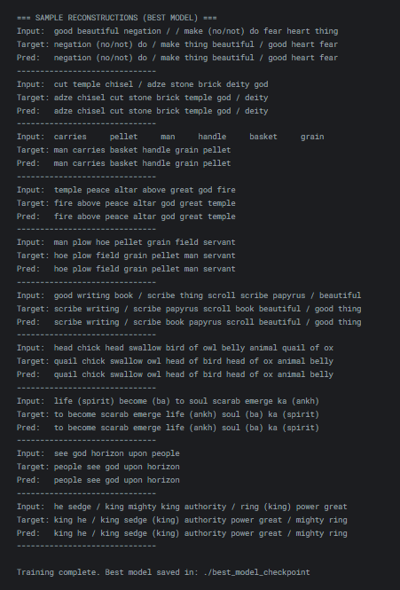
https://www.kaggle.com/code/sara1ahmed/bart-6-words-english

7_WORDS_RESULTS
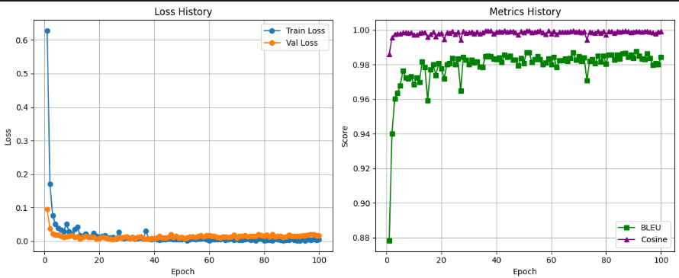

epoch | train_loss | val_loss | bleu | cosine
1 | 0.62835 | 0.095093 | 0.878128 | 0.985853
2 | 0.170217 | 0.036832 | 0.939898 | 0.995559
3 | 0.076021 | 0.022176 | 0.960297 | 0.997548
4 | 0.050775 | 0.018365 | 0.963384 | 0.99797
5 | 0.039959 | 0.01824 | 0.967917 | 0.997845
6 | 0.034575 | 0.015098 | 0.976452 | 0.998601
7 | 0.029588 | 0.012119 | 0.972396 | 0.998449
8 | 0.050766 | 0.013651 | 0.971876 | 0.998401
9 | 0.029516 | 0.015513 | 0.973213 | 0.998572
10 | 0.022456 | 0.017103 | 0.968438 | 0.997412
11 | 0.036196 | 0.011744 | 0.972342 | 0.997114
12 | 0.04303 | 0.013716 | 0.969913 | 0.99816
13 | 0.017011 | 0.007015 | 0.98182 | 0.998571
14 | 0.015838 | 0.01138 | 0.978346 | 0.998713
15 | 0.022109 | 0.014521 | 0.959261 | 0.995809
16 | 0.014357 | 0.010982 | 0.976933 | 0.997471
17 | 0.014262 | 0.012188 | 0.980019 | 0.998821
18 | 0.02304 | 0.01192 | 0.973929 | 0.996377
19 | 0.015807 | 0.007051 | 0.980676 | 0.99797
20 | 0.011343 | 0.008664 | 0.977651 | 0.998213
21 | 0.01594 | 0.011198 | 0.971872 | 0.994657
22 | 0.016688 | 0.010421 | 0.980212 | 0.998643
23 | 0.010637 | 0.008022 | 0.980852 | 0.99829
24 | 0.010948 | 0.00752 | 0.983731 | 0.999227
25 | 0.011389 | 0.005768 | 0.980022 | 0.997555
26 | 0.006984 | 0.00785 | 0.983235 | 0.99897
27 | 0.026673 | 0.010861 | 0.96488 | 0.994392
28 | 0.010891 | 0.010114 | 0.984265 | 0.999174
29 | 0.008252 | 0.011293 | 0.982717 | 0.998304
30 | 0.010707 | 0.012912 | 0.980134 | 0.99855
31 | 0.009063 | 0.008801 | 0.982702 | 0.998953
32 | 0.011357 | 0.009886 | 0.981005 | 0.997976
33 | 0.007125 | 0.008094 | 0.981864 | 0.998947
34 | 0.008255 | 0.011985 | 0.978748 | 0.997903
35 | 0.010074 | 0.014177 | 0.978329 | 0.998527
36 | 0.007087 | 0.007633 | 0.98466 | 0.99945
37 | 0.031403 | 0.007284 | 0.984871 | 0.999516
38 | 0.006146 | 0.007201 | 0.984681 | 0.999441
39 | 0.005567 | 0.007653 | 0.983199 | 0.997832
40 | 0.00602 | 0.008729 | 0.983048 | 0.998867
41 | 0.004525 | 0.009889 | 0.983895 | 0.999301
42 | 0.003845 | 0.01459 | 0.981381 | 0.998834
43 | 0.00528 | 0.01066 | 0.985639 | 0.999505
44 | 0.005667 | 0.009952 | 0.984444 | 0.998986
45 | 0.00617 | 0.011127 | 0.985097 | 0.999307
46 | 0.005872 | 0.019546 | 0.982745 | 0.999267
47 | 0.005108 | 0.011466 | 0.982776 | 0.998412
48 | 0.00549 | 0.014401 | 0.979323 | 0.997391
49 | 0.005781 | 0.010006 | 0.983661 | 0.999082
50 | 0.004979 | 0.012576 | 0.980716 | 0.998729
51 | 0.007231 | 0.008658 | 0.987023 | 0.999521
52 | 0.002297 | 0.010069 | 0.986871 | 0.999656
53 | 0.005451 | 0.013647 | 0.981298 | 0.998672
54 | 0.006366 | 0.014132 | 0.982911 | 0.998951
55 | 0.004958 | 0.012432 | 0.984532 | 0.999274
56 | 0.006208 | 0.014478 | 0.98287 | 0.999402
57 | 0.007295 | 0.016655 | 0.980205 | 0.998457
58 | 0.007943 | 0.012833 | 0.980955 | 0.997583
59 | 0.004179 | 0.016357 | 0.983495 | 0.9994
60 | 0.002096 | 0.016209 | 0.980046 | 0.998065
61 | 0.005774 | 0.015154 | 0.984514 | 0.999171
62 | 0.005421 | 0.014858 | 0.97838 | 0.997681
63 | 0.00423 | 0.012657 | 0.982394 | 0.998832
64 | 0.004788 | 0.010778 | 0.982453 | 0.998812
65 | 0.007731 | 0.01357 | 0.983235 | 0.998995
66 | 0.003802 | 0.013353 | 0.981955 | 0.998863
67 | 0.005053 | 0.011612 | 0.983548 | 0.999241
68 | 0.006356 | 0.012975 | 0.986853 | 0.999643
69 | 0.003842 | 0.01873 | 0.982864 | 0.998872
70 | 0.004502 | 0.010567 | 0.984744 | 0.999179
71 | 0.003818 | 0.015988 | 0.98199 | 0.998502
72 | 0.00268 | 0.014604 | 0.983957 | 0.999168
73 | 0.005486 | 0.017102 | 0.970942 | 0.994407
74 | 0.006413 | 0.012794 | 0.981908 | 0.998951
75 | 0.00277 | 0.015288 | 0.983007 | 0.998483
76 | 0.005845 | 0.014928 | 0.980581 | 0.998283
77 | 0.002148 | 0.014645 | 0.985092 | 0.999394
78 | 0.006221 | 0.020056 | 0.98167 | 0.998304
79 | 0.006444 | 0.01694 | 0.985011 | 0.999091
80 | 0.001945 | 0.014638 | 0.980529 | 0.997171
81 | 0.002701 | 0.018845 | 0.985685 | 0.999206
82 | 0.002862 | 0.013805 | 0.985649 | 0.999367
83 | 0.002273 | 0.019622 | 0.982647 | 0.998287
84 | 0.006388 | 0.013493 | 0.985668 | 0.999074
85 | 0.005231 | 0.015257 | 0.983402 | 0.998984
86 | 0.002712 | 0.015705 | 0.986324 | 0.999323
87 | 0.002061 | 0.012012 | 0.986833 | 0.999554
88 | 0.003853 | 0.014175 | 0.984442 | 0.999159
89 | 0.003948 | 0.01803 | 0.985712 | 0.998707
90 | 0.006939 | 0.014418 | 0.983742 | 0.99889
91 | 0.002514 | 0.014777 | 0.987703 | 0.99939
92 | 0.00162 | 0.014865 | 0.985158 | 0.999119
93 | 0.001267 | 0.015321 | 0.983465 | 0.999059
94 | 0.005037 | 0.017048 | 0.983128 | 0.999282
95 | 0.001006 | 0.016298 | 0.986463 | 0.999325
96 | 0.004283 | 0.018202 | 0.983854 | 0.998824
97 | 0.003257 | 0.020973 | 0.979577 | 0.9985
98 | 0.004953 | 0.01962 | 0.980864 | 0.997872
99 | 0.003802 | 0.017131 | 0.979953 | 0.998847
100 | 0.004397 | 0.017364 | 0.984264 | 0.99931

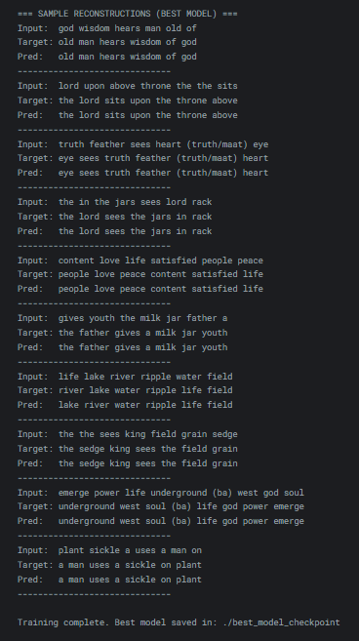
https://www.kaggle.com/code/soliharhossam/bart-7-words-english

8_WORDS_RESULTS
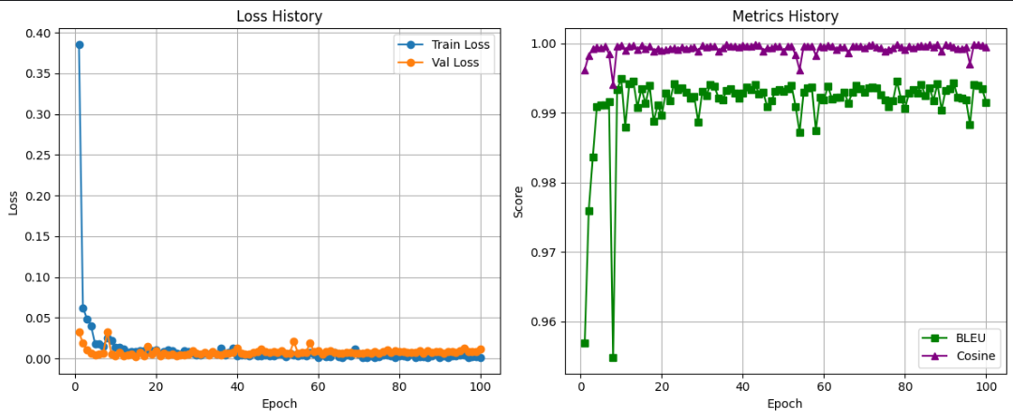

epoch | train_loss | val_loss | bleu | cosine
1 | 0.385809 | 0.032103 | 0.956863 | 0.9962
2 | 0.06229 | 0.018824 | 0.97589 | 0.998245
3 | 0.048631 | 0.010398 | 0.983571 | 0.999151
4 | 0.040089 | 0.006386 | 0.99091 | 0.999415
5 | 0.017748 | 0.004753 | 0.991136 | 0.999284
6 | 0.017566 | 0.005371 | 0.991113 | 0.999539
7 | 0.014472 | 0.006603 | 0.991589 | 0.998506
8 | 0.025135 | 0.032549 | 0.954758 | 0.994103
9 | 0.021644 | 0.005838 | 0.993285 | 0.999633
10 | 0.013661 | 0.002701 | 0.994901 | 0.99969
11 | 0.01351 | 0.007008 | 0.987948 | 0.998918
12 | 0.011113 | 0.003538 | 0.994154 | 0.999598
13 | 0.007851 | 0.003774 | 0.994518 | 0.999646
14 | 0.008406 | 0.004917 | 0.990772 | 0.999037
15 | 0.008889 | 0.002545 | 0.993459 | 0.999649
16 | 0.009138 | 0.00739 | 0.991316 | 0.999216
17 | 0.010015 | 0.0035 | 0.993907 | 0.999569
18 | 0.008393 | 0.014709 | 0.988745 | 0.998861
19 | 0.009929 | 0.005208 | 0.991089 | 0.999265
20 | 0.010334 | 0.009437 | 0.989668 | 0.99892
21 | 0.005263 | 0.003033 | 0.992848 | 0.999083
22 | 0.008382 | 0.006804 | 0.991691 | 0.999163
23 | 0.01006 | 0.00479 | 0.99415 | 0.999319
24 | 0.009676 | 0.005242 | 0.99326 | 0.999144
25 | 0.006359 | 0.003394 | 0.993564 | 0.99946
26 | 0.005064 | 0.004177 | 0.9929 | 0.999264
27 | 0.009113 | 0.004633 | 0.992148 | 0.999273
28 | 0.008038 | 0.005134 | 0.992394 | 0.999471
29 | 0.006126 | 0.009833 | 0.988702 | 0.99888
30 | 0.004694 | 0.006522 | 0.993111 | 0.999693
31 | 0.00413 | 0.005677 | 0.992469 | 0.999471
32 | 0.006141 | 0.006937 | 0.994066 | 0.999597
33 | 0.005626 | 0.004702 | 0.993755 | 0.999525
34 | 0.00712 | 0.008344 | 0.992144 | 0.998891
35 | 0.005153 | 0.005727 | 0.991852 | 0.999373
36 | 0.01224 | 0.004602 | 0.993151 | 0.999776
37 | 0.004175 | 0.006101 | 0.993421 | 0.99963
38 | 0.007199 | 0.006128 | 0.992848 | 0.999608
39 | 0.012688 | 0.007837 | 0.992124 | 0.999496
40 | 0.003521 | 0.012941 | 0.992856 | 0.999696
41 | 0.00415 | 0.006748 | 0.993656 | 0.999619
42 | 0.004708 | 0.005753 | 0.99336 | 0.999542
43 | 0.003526 | 0.005755 | 0.994093 | 0.999835
44 | 0.006214 | 0.00765 | 0.99275 | 0.999676
45 | 0.003326 | 0.008171 | 0.992975 | 0.998893
46 | 0.003294 | 0.011221 | 0.990898 | 0.999334
47 | 0.004146 | 0.008187 | 0.991696 | 0.999292
48 | 0.003008 | 0.006992 | 0.993029 | 0.999561
49 | 0.002898 | 0.008719 | 0.993287 | 0.99952
50 | 0.005206 | 0.007177 | 0.993021 | 0.998792
51 | 0.005102 | 0.009118 | 0.993474 | 0.999565
52 | 0.001701 | 0.006108 | 0.993895 | 0.999629
53 | 0.005982 | 0.00674 | 0.990912 | 0.998328
54 | 0.004679 | 0.020798 | 0.987174 | 0.996172
55 | 0.003732 | 0.006825 | 0.992993 | 0.999594
56 | 0.004786 | 0.007623 | 0.993595 | 0.999632
57 | 0.002884 | 0.007502 | 0.993668 | 0.999637
58 | 0.007512 | 0.019198 | 0.987465 | 0.998256
59 | 0.004923 | 0.007987 | 0.992232 | 0.999554
60 | 0.001484 | 0.009775 | 0.991878 | 0.999502
61 | 0.003745 | 0.005833 | 0.993853 | 0.999701
62 | 0.001984 | 0.008117 | 0.991934 | 0.999621
63 | 0.002407 | 0.009522 | 0.992263 | 0.999081
64 | 0.007706 | 0.007554 | 0.992269 | 0.999448
65 | 0.002496 | 0.005904 | 0.993012 | 0.99947
66 | 0.000925 | 0.006305 | 0.991408 | 0.998563
67 | 0.004167 | 0.007187 | 0.992921 | 0.999598
68 | 0.003283 | 0.00698 | 0.993879 | 0.999546
69 | 0.011103 | 0.006785 | 0.993445 | 0.99959
70 | 0.005409 | 0.006005 | 0.992935 | 0.999359
71 | 0.000768 | 0.006281 | 0.993518 | 0.999723
72 | 0.000859 | 0.007767 | 0.993652 | 0.999764
73 | 0.002836 | 0.006643 | 0.993603 | 0.999437
74 | 0.001032 | 0.008522 | 0.992588 | 0.999351
75 | 0.002457 | 0.006364 | 0.991873 | 0.998884
76 | 0.003823 | 0.008875 | 0.990812 | 0.999124
77 | 0.004446 | 0.010656 | 0.99168 | 0.999283
78 | 0.003275 | 0.007426 | 0.994543 | 0.999857
79 | 0.001549 | 0.008985 | 0.991985 | 0.999459
80 | 0.003057 | 0.008943 | 0.990627 | 0.999072
81 | 0.003131 | 0.008697 | 0.992873 | 0.999585
82 | 0.001909 | 0.007702 | 0.993281 | 0.99937
83 | 0.005032 | 0.0074 | 0.992859 | 0.999545
84 | 0.001565 | 0.007501 | 0.994077 | 0.999698
85 | 0.002159 | 0.009045 | 0.992451 | 0.999528
86 | 0.002485 | 0.006772 | 0.993618 | 0.999827
87 | 0.001063 | 0.00904 | 0.991772 | 0.999465
88 | 0.002926 | 0.007033 | 0.994119 | 0.999817
89 | 0.0053 | 0.008622 | 0.990408 | 0.998807
90 | 0.000833 | 0.008572 | 0.993255 | 0.999796
91 | 0.003136 | 0.006793 | 0.993421 | 0.999653
92 | 0.001588 | 0.008243 | 0.994283 | 0.999513
93 | 0.002901 | 0.007996 | 0.99218 | 0.999164
94 | 0.003359 | 0.007674 | 0.992117 | 0.999261
95 | 0.004415 | 0.009138 | 0.991898 | 0.999432
96 | 0.003759 | 0.012473 | 0.988298 | 0.997018
97 | 0.001076 | 0.008465 | 0.994093 | 0.999829
98 | 0.001725 | 0.008741 | 0.993918 | 0.999812
99 | 0.002378 | 0.00827 | 0.99343 | 0.999711
100 | 0.001117 | 0.011659 | 0.991532 | 0.999459

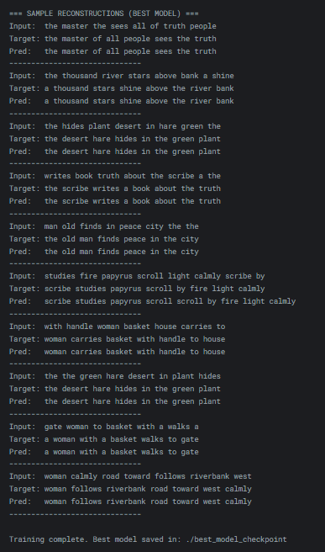
https://www.kaggle.com/code/asd4zxc/bart-8-words-english

9_WORDS_RESULTS
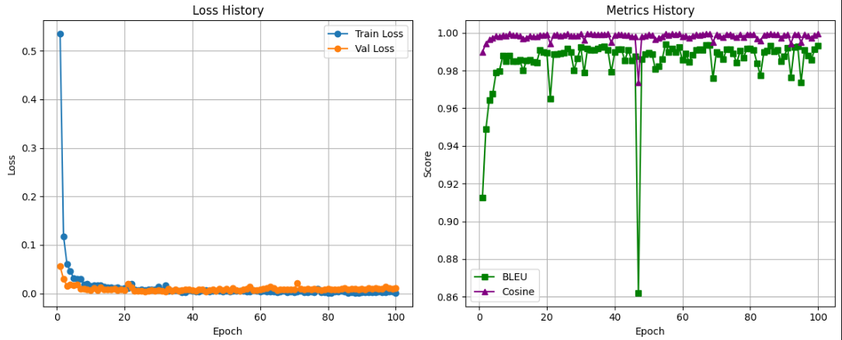

epoch | train_loss | val_loss | bleu | cosine
1 | 0.535598 | 0.055684 | 0.912547 | 0.989777
2 | 0.11806 | 0.030091 | 0.948887 | 0.99442
3 | 0.061057 | 0.015736 | 0.964461 | 0.996418
4 | 0.046103 | 0.018375 | 0.967506 | 0.997311
5 | 0.031791 | 0.016281 | 0.978789 | 0.998374
6 | 0.02957 | 0.018505 | 0.979849 | 0.997993
7 | 0.030418 | 0.0092 | 0.988018 | 0.998892
8 | 0.018663 | 0.009169 | 0.984904 | 0.998404
9 | 0.019294 | 0.007792 | 0.987817 | 0.999376
10 | 0.016075 | 0.007282 | 0.985049 | 0.99885
11 | 0.017093 | 0.010573 | 0.985018 | 0.998762
12 | 0.016501 | 0.006263 | 0.985505 | 0.998411
13 | 0.016321 | 0.012141 | 0.980091 | 0.996835
14 | 0.013627 | 0.008874 | 0.98539 | 0.997377
15 | 0.0129 | 0.007678 | 0.98565 | 0.998485
16 | 0.012262 | 0.007953 | 0.984476 | 0.998042
17 | 0.010576 | 0.009572 | 0.984298 | 0.997979
18 | 0.013304 | 0.007293 | 0.990863 | 0.998901
19 | 0.009965 | 0.007914 | 0.989923 | 0.998922
20 | 0.011521 | 0.007212 | 0.989537 | 0.999203
21 | 0.011613 | 0.019628 | 0.964958 | 0.994297
22 | 0.019319 | 0.013122 | 0.988852 | 0.99899
23 | 0.00845 | 0.005698 | 0.988583 | 0.999065
24 | 0.007468 | 0.005975 | 0.989086 | 0.998612
25 | 0.00811 | 0.005529 | 0.9896 | 0.99892
26 | 0.007246 | 0.003904 | 0.991622 | 0.99947
27 | 0.008113 | 0.005063 | 0.989886 | 0.998525
28 | 0.007706 | 0.00626 | 0.980102 | 0.998257
29 | 0.008773 | 0.004993 | 0.98638 | 0.998492
30 | 0.013382 | 0.006261 | 0.992392 | 0.999489
31 | 0.006606 | 0.004884 | 0.978795 | 0.99613
32 | 0.017392 | 0.004458 | 0.991658 | 0.99954
33 | 0.004935 | 0.009655 | 0.990955 | 0.999465
34 | 0.004837 | 0.004848 | 0.990995 | 0.99901
35 | 0.006688 | 0.008579 | 0.991732 | 0.999108
36 | 0.005086 | 0.004791 | 0.992345 | 0.999336
37 | 0.002862 | 0.006217 | 0.99288 | 0.999353
38 | 0.003036 | 0.00788 | 0.990766 | 0.999449
39 | 0.006904 | 0.008485 | 0.979228 | 0.994973
40 | 0.005709 | 0.006256 | 0.989676 | 0.998756
41 | 0.00406 | 0.005362 | 0.991257 | 0.99902
42 | 0.003285 | 0.00756 | 0.991352 | 0.999145
43 | 0.007071 | 0.008639 | 0.985376 | 0.998701
44 | 0.007313 | 0.004028 | 0.990889 | 0.998987
45 | 0.00432 | 0.007402 | 0.985406 | 0.998091
46 | 0.00571 | 0.007716 | 0.987574 | 0.998018
47 | 0.005402 | 0.00596 | 0.861818 | 0.973845
48 | 0.005322 | 0.009795 | 0.986032 | 0.998145
49 | 0.004064 | 0.006646 | 0.988565 | 0.998526
50 | 0.00495 | 0.01018 | 0.989418 | 0.999141
51 | 0.00437 | 0.004992 | 0.988798 | 0.998938
52 | 0.005541 | 0.011746 | 0.98091 | 0.996451
53 | 0.005634 | 0.007163 | 0.982492 | 0.997136
54 | 0.005036 | 0.005498 | 0.985895 | 0.998227
55 | 0.005293 | 0.008126 | 0.993934 | 0.999662
56 | 0.00402 | 0.010281 | 0.989719 | 0.998767
57 | 0.003598 | 0.014704 | 0.991592 | 0.99959
58 | 0.007387 | 0.007387 | 0.989839 | 0.99915
59 | 0.004726 | 0.00667 | 0.992391 | 0.999429
60 | 0.004438 | 0.008497 | 0.985583 | 0.998133
61 | 0.005011 | 0.010299 | 0.989179 | 0.998525
62 | 0.003922 | 0.011323 | 0.984442 | 0.997457
63 | 0.00336 | 0.013513 | 0.988402 | 0.998542
64 | 0.003218 | 0.010814 | 0.990776 | 0.999049
65 | 0.00276 | 0.007328 | 0.991264 | 0.998941
66 | 0.003314 | 0.007753 | 0.990918 | 0.999078
67 | 0.005195 | 0.007864 | 0.993378 | 0.999579
68 | 0.003103 | 0.007818 | 0.99356 | 0.999605
69 | 0.003397 | 0.007617 | 0.975926 | 0.995177
70 | 0.003115 | 0.008921 | 0.989891 | 0.999079
71 | 0.004031 | 0.021122 | 0.988689 | 0.998376
72 | 0.004747 | 0.009219 | 0.986064 | 0.99779
73 | 0.002557 | 0.00788 | 0.991271 | 0.999365
74 | 0.002386 | 0.009222 | 0.991333 | 0.99927
75 | 0.004412 | 0.008727 | 0.989049 | 0.998591
76 | 0.002021 | 0.010313 | 0.984043 | 0.997744
77 | 0.009042 | 0.008474 | 0.99041 | 0.99921
78 | 0.002293 | 0.007106 | 0.986841 | 0.99777
79 | 0.002352 | 0.008131 | 0.991521 | 0.999324
80 | 0.000481 | 0.010118 | 0.991862 | 0.999357
81 | 0.001134 | 0.00841 | 0.990841 | 0.999322
82 | 0.003917 | 0.008422 | 0.98385 | 0.997028
83 | 0.003735 | 0.008852 | 0.977511 | 0.99591
84 | 0.004764 | 0.009582 | 0.989884 | 0.998982
85 | 0.004182 | 0.010999 | 0.990589 | 0.999366
86 | 0.001355 | 0.008006 | 0.993132 | 0.999446
87 | 0.00237 | 0.00935 | 0.990211 | 0.99924
88 | 0.001377 | 0.009516 | 0.990893 | 0.999048
89 | 0.001623 | 0.00763 | 0.98484 | 0.997437
90 | 0.002111 | 0.009098 | 0.987493 | 0.998803
91 | 0.003132 | 0.008494 | 0.99207 | 0.999272
92 | 0.002691 | 0.011545 | 0.97644 | 0.994346
93 | 0.002258 | 0.009408 | 0.992464 | 0.999302
94 | 0.001962 | 0.011498 | 0.992942 | 0.999329
95 | 0.003294 | 0.009876 | 0.97385 | 0.995052
96 | 0.002235 | 0.009697 | 0.991086 | 0.999273
97 | 0.001976 | 0.014011 | 0.988034 | 0.998285
98 | 0.003408 | 0.011045 | 0.985818 | 0.997344
99 | 0.004605 | 0.009551 | 0.991341 | 0.99867
100 | 0.001241 | 0.010482 | 0.993352 | 0.99946

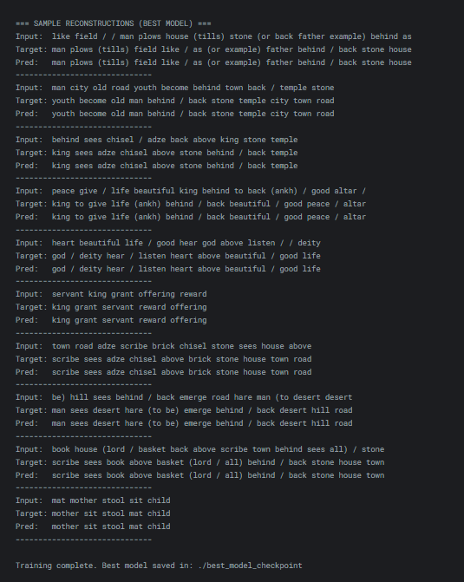
https://www.kaggle.com/code/ahmedkhaledeissa/bart-9-words-english

10_WORDS_RESULTS
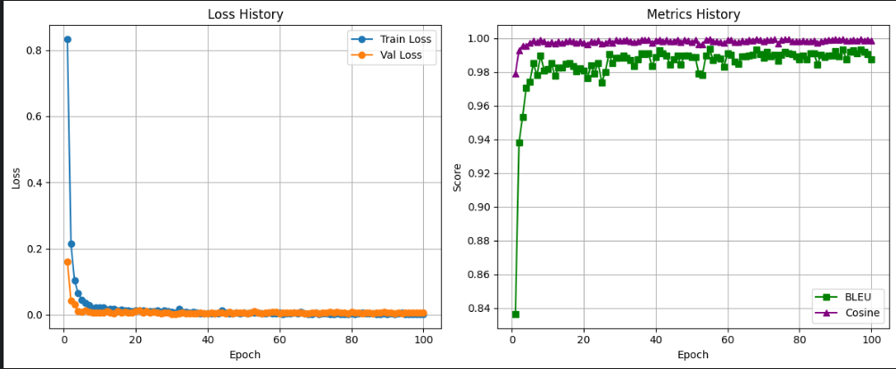

epoch | train_loss | val_loss | bleu | cosine
1 | 0.833499 | 0.161712 | 0.836098 | 0.979035
2 | 0.213977 | 0.042113 | 0.938094 | 0.992943
3 | 0.103077 | 0.031735 | 0.953359 | 0.995709
4 | 0.065172 | 0.010576 | 0.970715 | 0.99555
5 | 0.045796 | 0.00837 | 0.974309 | 0.997395
6 | 0.036702 | 0.012463 | 0.985075 | 0.998503
7 | 0.029269 | 0.008111 | 0.977986 | 0.997604
8 | 0.021373 | 0.006768 | 0.989821 | 0.998946
9 | 0.02234 | 0.005958 | 0.980832 | 0.998356
10 | 0.022185 | 0.005802 | 0.981883 | 0.99694
11 | 0.022225 | 0.006338 | 0.985419 | 0.997827
12 | 0.015942 | 0.011871 | 0.977582 | 0.996977
13 | 0.018152 | 0.007315 | 0.982635 | 0.998265
14 | 0.017136 | 0.00417 | 0.982488 | 0.997125
15 | 0.014271 | 0.010508 | 0.984663 | 0.99818
16 | 0.014892 | 0.006923 | 0.985298 | 0.998429
17 | 0.014455 | 0.008375 | 0.983497 | 0.998207
18 | 0.012936 | 0.007729 | 0.980281 | 0.997313
19 | 0.012218 | 0.005978 | 0.982137 | 0.998197
20 | 0.013647 | 0.012318 | 0.980719 | 0.99748
21 | 0.012831 | 0.012888 | 0.976229 | 0.996554
22 | 0.014328 | 0.007456 | 0.984039 | 0.998145
23 | 0.010749 | 0.010885 | 0.979256 | 0.997825
24 | 0.011354 | 0.007755 | 0.98549 | 0.998416
25 | 0.010771 | 0.008016 | 0.973794 | 0.996935
26 | 0.013012 | 0.007108 | 0.980151 | 0.997358
27 | 0.008253 | 0.00485 | 0.990699 | 0.998431
28 | 0.01337 | 0.007463 | 0.985165 | 0.997321
29 | 0.012193 | 0.007025 | 0.988504 | 0.998995
30 | 0.008555 | 0.002835 | 0.988233 | 0.998481
31 | 0.005781 | 0.002687 | 0.98978 | 0.998518
32 | 0.017121 | 0.004642 | 0.988229 | 0.999182
33 | 0.008218 | 0.006619 | 0.98691 | 0.998284
34 | 0.007946 | 0.003971 | 0.983687 | 0.997744
35 | 0.007869 | 0.00537 | 0.987377 | 0.998206
36 | 0.009933 | 0.003522 | 0.991191 | 0.999026
37 | 0.007216 | 0.004276 | 0.990595 | 0.99891
38 | 0.004813 | 0.007493 | 0.990993 | 0.999079
39 | 0.005006 | 0.004826 | 0.983431 | 0.997129
40 | 0.004532 | 0.005413 | 0.988849 | 0.998687
41 | 0.004372 | 0.0065 | 0.992851 | 0.999272
42 | 0.004997 | 0.005163 | 0.991081 | 0.998392
43 | 0.003725 | 0.006969 | 0.989731 | 0.998941
44 | 0.013303 | 0.006265 | 0.98445 | 0.998097
45 | 0.006925 | 0.00468 | 0.987442 | 0.998413
46 | 0.004256 | 0.008462 | 0.989787 | 0.999297
47 | 0.004406 | 0.004986 | 0.984547 | 0.997556
48 | 0.007255 | 0.007621 | 0.989601 | 0.998993
49 | 0.004827 | 0.006883 | 0.989765 | 0.998718
50 | 0.006586 | 0.006196 | 0.988905 | 0.997813
51 | 0.003774 | 0.004941 | 0.988944 | 0.99892
52 | 0.00585 | 0.007242 | 0.979045 | 0.996237
53 | 0.007795 | 0.010209 | 0.978384 | 0.996621
54 | 0.005966 | 0.006617 | 0.989783 | 0.99923
55 | 0.003477 | 0.004828 | 0.993698 | 0.999654
56 | 0.0039 | 0.006028 | 0.986864 | 0.998194
57 | 0.007515 | 0.007747 | 0.988876 | 0.998338
58 | 0.00502 | 0.008254 | 0.988041 | 0.997764
59 | 0.003476 | 0.010042 | 0.983137 | 0.997156
60 | 0.006505 | 0.004817 | 0.99122 | 0.998951
61 | 0.002753 | 0.006074 | 0.990067 | 0.99903
62 | 0.004332 | 0.00621 | 0.986339 | 0.997687
63 | 0.004094 | 0.006594 | 0.984978 | 0.997746
64 | 0.006125 | 0.006082 | 0.989348 | 0.998631
65 | 0.003774 | 0.006613 | 0.989338 | 0.998122
66 | 0.007942 | 0.007159 | 0.989742 | 0.999093
67 | 0.003389 | 0.004817 | 0.990008 | 0.998844
68 | 0.002527 | 0.004444 | 0.993311 | 0.999473
69 | 0.002857 | 0.007848 | 0.990432 | 0.999197
70 | 0.006008 | 0.00612 | 0.98847 | 0.998152
71 | 0.003041 | 0.005001 | 0.991754 | 0.999133
72 | 0.005007 | 0.007121 | 0.989322 | 0.998893
73 | 0.005623 | 0.00629 | 0.990138 | 0.999325
74 | 0.003219 | 0.008013 | 0.986589 | 0.997011
75 | 0.001949 | 0.006106 | 0.990188 | 0.998928
76 | 0.004736 | 0.008802 | 0.991742 | 0.999429
77 | 0.003133 | 0.007734 | 0.991181 | 0.99955
78 | 0.001745 | 0.007627 | 0.9906 | 0.99821
79 | 0.002557 | 0.005353 | 0.98926 | 0.998221
80 | 0.003431 | 0.008865 | 0.98765 | 0.998331
81 | 0.003315 | 0.006198 | 0.989627 | 0.998599
82 | 0.004328 | 0.007494 | 0.98756 | 0.998263
83 | 0.006464 | 0.005588 | 0.991269 | 0.998328
84 | 0.003514 | 0.006486 | 0.99125 | 0.998815
85 | 0.005005 | 0.005717 | 0.98447 | 0.997187
86 | 0.003898 | 0.004836 | 0.990347 | 0.998167
87 | 0.001982 | 0.005945 | 0.988799 | 0.998807
88 | 0.001459 | 0.005778 | 0.989774 | 0.999224
89 | 0.004167 | 0.008368 | 0.989821 | 0.999086
90 | 0.001501 | 0.006373 | 0.99255 | 0.999373
91 | 0.003903 | 0.00683 | 0.989416 | 0.999197
92 | 0.00262 | 0.005143 | 0.993512 | 0.999457
93 | 0.004427 | 0.006191 | 0.987702 | 0.998535
94 | 0.006282 | 0.00494 | 0.992118 | 0.998698
95 | 0.002619 | 0.006746 | 0.992844 | 0.998934
96 | 0.002472 | 0.006975 | 0.990981 | 0.99873
97 | 0.00249 | 0.006161 | 0.99309 | 0.999652
98 | 0.00281 | 0.006298 | 0.991858 | 0.998667
99 | 0.002306 | 0.006486 | 0.99049 | 0.999231
100 | 0.001673 | 0.006473 | 0.987588 | 0.998853

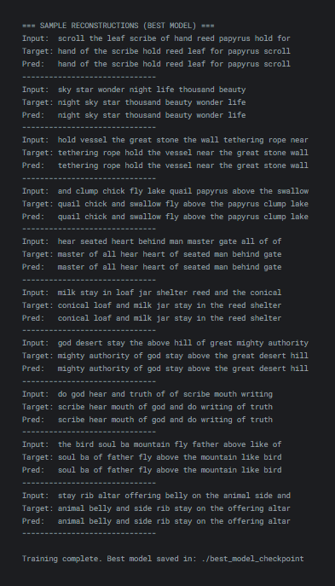
https://www.kaggle.com/code/ahmedkhaled43/bart-10-words-english

All_words_english
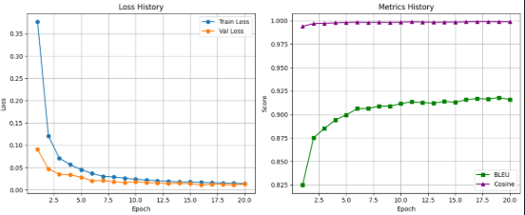

epoch | train_loss | val_loss | bleu | cosine
1 | 0.377043 | 0.090675 | 0.824745 | 0.993963
2 | 0.120747 | 0.046974 | 0.875055 | 0.996817
3 | 0.070977 | 0.035158 | 0.885182 | 0.997048
4 | 0.05664 | 0.03389 | 0.894121 | 0.997684
5 | 0.045589 | 0.028588 | 0.899493 | 0.997965
6 | 0.036897 | 0.02034 | 0.906221 | 0.998432
7 | 0.030606 | 0.021007 | 0.906405 | 0.99804
8 | 0.029082 | 0.01829 | 0.908855 | 0.99826
9 | 0.026474 | 0.016364 | 0.908816 | 0.998099
10 | 0.023748 | 0.018279 | 0.911467 | 0.998439
11 | 0.022186 | 0.016244 | 0.913383 | 0.998722
12 | 0.020595 | 0.015561 | 0.9126 | 0.998548
13 | 0.01933 | 0.014065 | 0.911949 | 0.998226
14 | 0.017865 | 0.01502 | 0.913909 | 0.998473
15 | 0.017904 | 0.013818 | 0.91289 | 0.998476
16 | 0.016821 | 0.010948 | 0.915786 | 0.998685
17 | 0.016068 | 0.012458 | 0.916934 | 0.998978
18 | 0.015404 | 0.012263 | 0.916383 | 0.998899
19 | 0.01506 | 0.011171 | 0.917956 | 0.998756
20 | 0.014012 | 0.012885 | 0.915947 | 0.998776

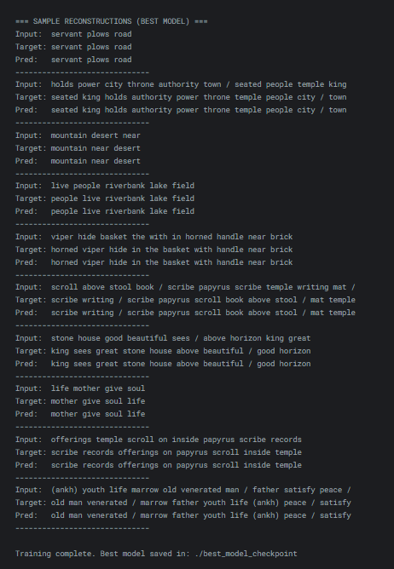

https://www.kaggle.com/code/khaledeissa1/all-words-words-english

📊 1. Training Dynamics (Learning Behavior)
These show how the model learned over time.

A. Loss Curves
From:
history['train_loss']
history['val_loss']

Report:
- Training Loss vs Epoch
- Validation Loss vs Epoch
- Epoch where best validation loss occurred
- Value of best validation loss
Why it matters: Shows convergence, overfitting/underfitting.

B. Metric Curves
From:
history['bleu']
history['cosine'] # if enabled

Report:
- BLEU score vs Epoch
- Cosine similarity vs Epoch (if calculated)
- Best BLEU score achieved
- Epoch of best BLEU
Why it matters: Shows actual reconstruction quality, not just loss.

🏆 2. Best Model Information
From checkpoint logic:
if avg_val_loss < best_val_loss:
model.save_pretrained(SAVE_DIR)

Report:
- Model used: facebook/bart-base
- Best model selected based on: Lowest Validation Loss
- Path of saved best model: ./best_model_checkpoint
- Epoch number when best model was saved

🧪 3. Final Evaluation Metrics (Validation Set)
From:
bleu, cosine = calculate_metrics(predictions, references)

Report final values (from best epoch or last epoch depending on your choice):
- Final Validation BLEU Score (mean)
- Final Validation Cosine Similarity (mean, if used)
- Final Validation Loss
Put these in a clean table:
Metric | Value
Validation Loss | X.XXXX
BLEU Score | X.XXXX
Cosine Similarity | X.XXXX

✍️ 4. Qualitative Results (Sample Reconstructions)
From:
print("=== SAMPLE RECONSTRUCTIONS ===")
Input / Target / Pred

Report:
Include 5–10 example reconstructions in a table:
Shuffled Input | Ground Truth Sentence | Model Prediction
Why it matters: Shows real behavior, fluency, and common errors.

📁 5. Saved Experimental Artifacts
Mention these files in your report:
File | Contents
training_metrics.csv | Epoch-wise loss and metric history
reconstruction_results.csv | Full validation predictions
./best_model_checkpoint/ | Final trained model + tokenizer

⚙️ 6. Experimental Setup Summary (from config)
Always required in reports:
Parameter | Value
Model | BART-base
Max sequence length | 32
Batch size | 16
Epochs | 100
Learning rate | 5e-5
Optimizer | AdamW
Scheduler | None
Augmentation | Word shuffling (10 variants per sentence)
Train/Val split | 80% / 20%

🧠 7. Dataset Statistics
From earlier cells but essential for reporting:
- Total dataset size after augmentation
- Number of training samples
- Number of validation samples
- Average sentence length (optional but good)

🎯 Minimum Must-Have Figures for the Report
- Loss vs Epoch graph
- BLEU (and Cosine) vs Epoch graph
- Table of final metrics
- Table of sample reconstructions

